Artjoms – Add Screen
Layout: Form title is at the top of the form. Doctor details input is placed on the top left of the form, Personal & Surgery details placed side by side underneath the Doc details. Buttons are at the bottom left of the form.
Alignment: The form is aligned to the centre of the page using the ‘Margin’ element in CSS, allows for clearer visibility.
Background: Background of the screen is plain white with the form having a slight blue tint to it in order to have clearer visibility and match the blue theme of the page.
Font: Font style is set to Arial for the form for clear readability and the nav bar is set to times new Roman for a unique style.
Font size: The title of the form is set to 36px, input titles are at 27px and input fields are 18px.
Input Fields: Border has been set to none with an inset shadow to make it seem like the input has been cut out of the form.
Buttons: On the bottom left side of the screen with slight spacing in between. On hover the button highlights and upon press it highlights a little more for user interactivity. Background colour is blue to match the colour palette of the page.
Borders: Border style set to none and the corners are rounded with box shadow around it to give a floating effect.

Artjoms – Amend Screen
Layout: Form title is at the top of the form. Doctor details input is placed on the top left of the form, on the right of it is the Amend/View button with the list box on top of it. Personal & Surgery details placed side by side underneath the Doc details. Save Changes button is at the bottom left of the form.
Alignment: The form is aligned to the centre of the page using the ‘Margin’ element in CSS, allows for clearer visibility.
Background: Background of the screen is plain white with the form having a slight blue tint to it in order to have clearer visibility and match the blue theme of the page.
Font: Font style is set to Arial for the form for clear readability and the nav bar is set to times new Roman for a unique style.
Font size: The title of the form is set to 36px, input titles are at 27px and input fields are 18px.
Input Fields: Border has been set to none with an inset shadow to make it seem like the input has been cut out of the form.
List Box: The font size has been increased to make the list box appear larger, 18px.
Amend/View Button: Same look as the Save Changes, placed under the list box and when pressed changes to View or Amend.
Save Changes: On the bottom left side of the screen. On hover the button highlights and upon press it highlights a little more for user interactivity. Background colour is blue to match the colour palette of the page.
Borders: Border style set to none and the corners are rounded with box shadow around it to give a floating effect.

Artjoms – Delete Screen
Layout: Form title is at the top of the form. Doctor details input is placed on the top left of the form, on the right of it is the list box. Personal & Surgery details placed side by side underneath the Doc details. Delete button is placed at the bottom left of the form.
Alignment: The form is aligned to the centre of the page using the ‘Margin’ element in CSS, allows for clearer visibility.
Background: Background of the screen is plain white with the form having a slight blue tint to it in order to have clearer visibility and match the blue theme of the page.
Font: Font style is set to Arial for the form for clear readability and the nav bar is set to times new Roman for a unique style.
Font size: The title of the form is set to 36px, input titles are at 27px and input fields are 18px.
Input Fields: Border has been set to none with an inset shadow to make it seem like the input has been cut out of the form.
List Box: The font size has been increased to make the list box appear larger, 18px.
Amend/View Button: Same look as the Save Changes, placed under the list box and when pressed changes to View or Amend.
Save Changes: On the bottom left side of the screen. On hover the button highlights and upon press it highlights a little more for user interactivity. Background colour is blue to match the colour palette of the page.
Borders: Border style set to none and the corners are rounded with box shadow around it to give a floating effect.
Artjoms – Reorder Screen
Layout: Title at the top of the container, on the left is the supplier list box, on the right is the drug list box with the quantity of reorder below it and under all of that is the table which is centred.
Alignment: The list boxes are in a grid display with the Supplier list box taking up 2/3 of the container. Table is aligned to the centre with 25px of margin to the left and right
Background: Background of the screen is plain white with the form having a slight blue tint to it in order to have clearer visibility and match the blue theme of the page.
Font: Set to Arial
Font size: The title of the form is set to 36px, input titles are at 27px and input fields are 18px.
Input Fields:
Supplier list Box: On the left of the form, box font size is 20px
Drug list Box: On the right of the form, box font size is 20px
Table: Underneath the two list boxes, zebra appearance for readability and a dark blue background for column titles.
Borders: Border style set to none and the corners are rounded with box shadow around it to give a floating effect.
Artjoms – Reorder Letter Screen
Layout: Pharmacy address on top right, supplier address on the left and slightly below the pharmacy one. Order number is printed in the middle of its line. A table printing out all of the drugs that have been reordered with the total cost. Pharmacist’s name at the end with a return button.
Background: Background of the screen is plain white with the letter having a blue background in order to have clearer visibility and match the blue theme of the page.
Font: Set to Arial
Font size: The title of the form is set to 36px, input titles are at 27px and input fields are 18px.
Borders: solid grey border.

Artjoms – Menu Screen
Layout: split into 2 nav bars, top one is a darker blue with the name of the pharmacy. Bottom one has all of the fields that split off into more fields.
Nav bar Alignment(top): Text is set to the centre and middle of the bar.
Nav bar Alignment(bottom): Fields are placed into a flex box that adds even space all around the text.
Background (top): Set to a darker blue.
Background (bottom): Set to a lighter blue.
Font: Set to times new Roman for a unique style.
Font size: Top bar is set to 32px and the bottom is set to 19.2px
Artjoms – Under construction Screen
Layout: centred in the middle of the page.
Alignment: Text is set to the centre and middle of the bar.
Background: default white.
Font: Set to times new Roman for a unique style.
Font size: 50px on the ‘construction’ text for clear visibility.
Border: Set to an outset style with a dodger blue colour.

ARTJOMS CODE
Add Screen:
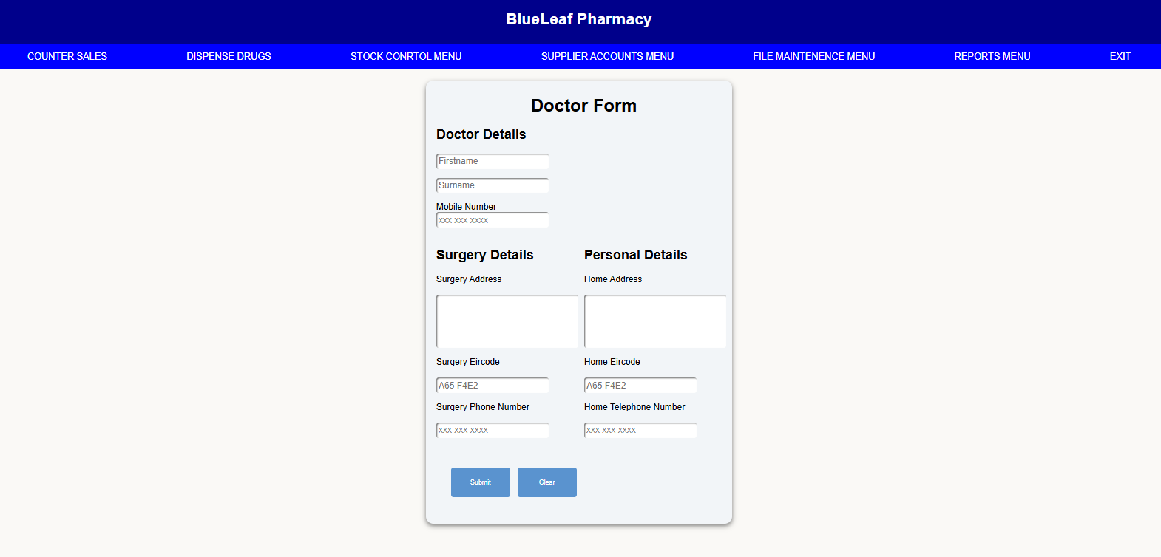
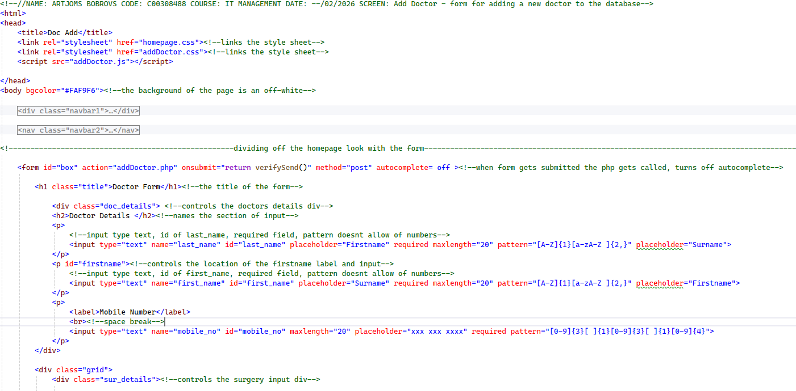
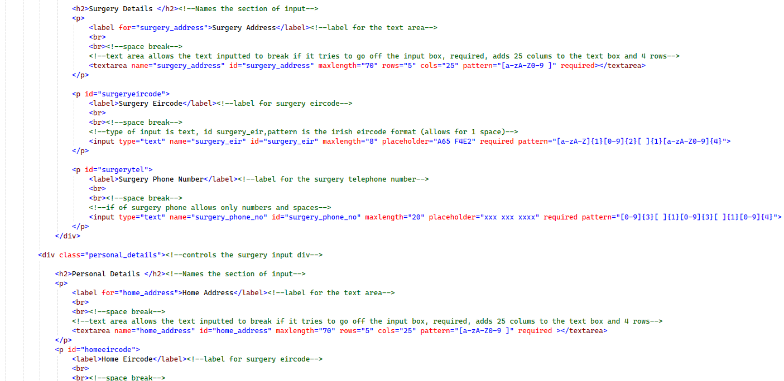
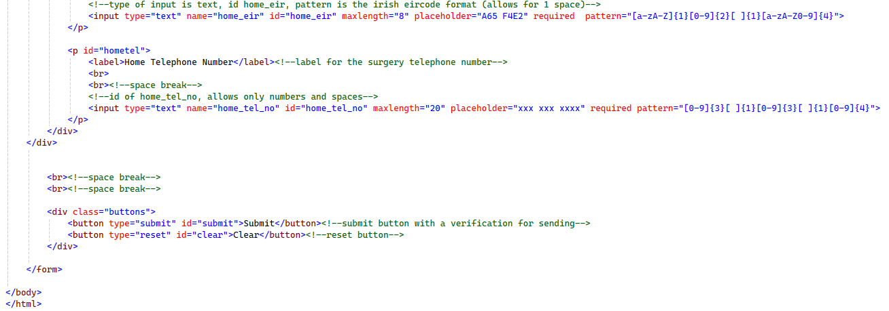

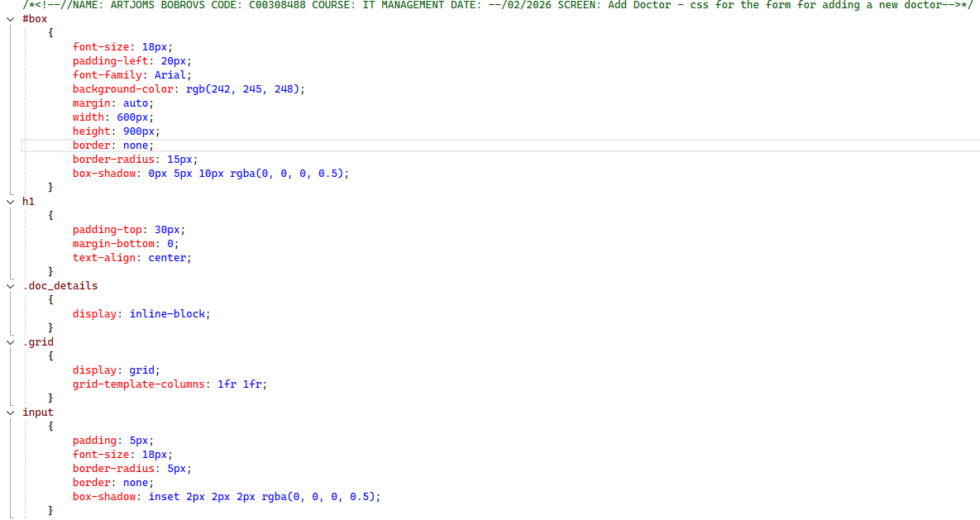
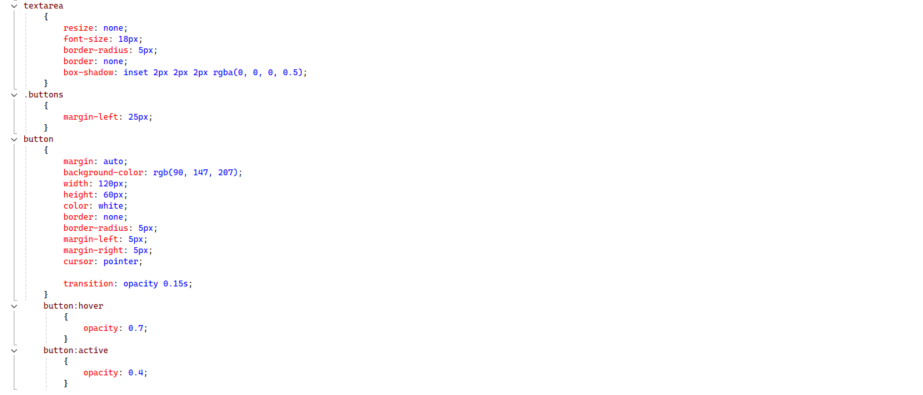
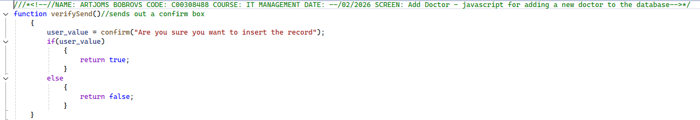
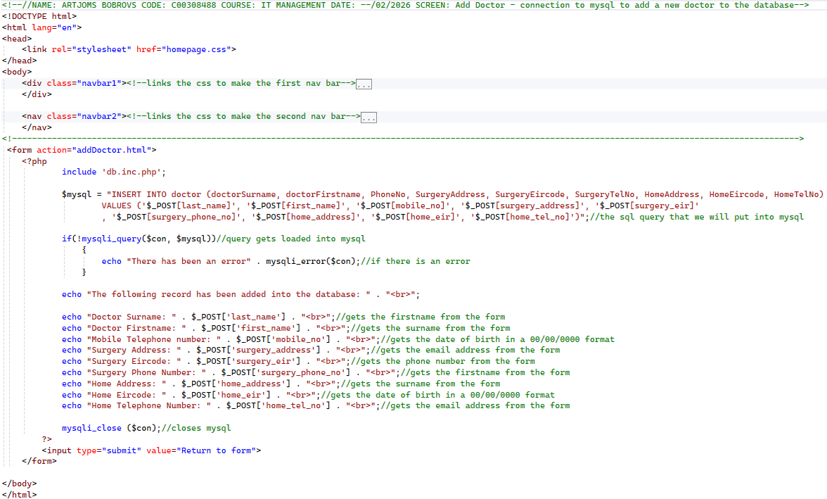
Amend Screen:
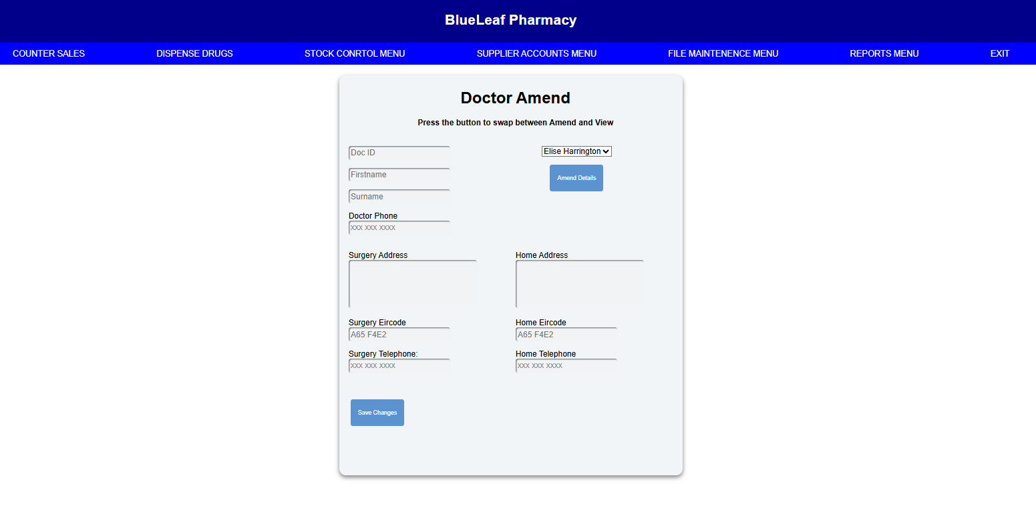
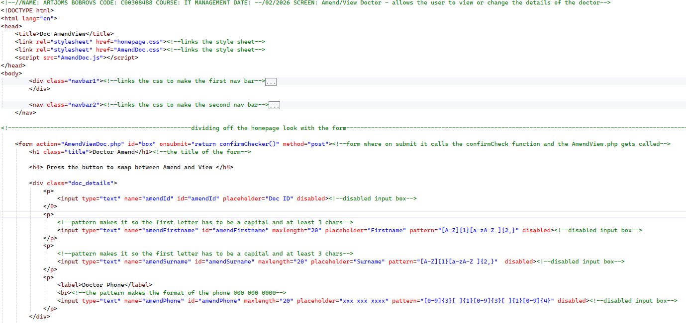
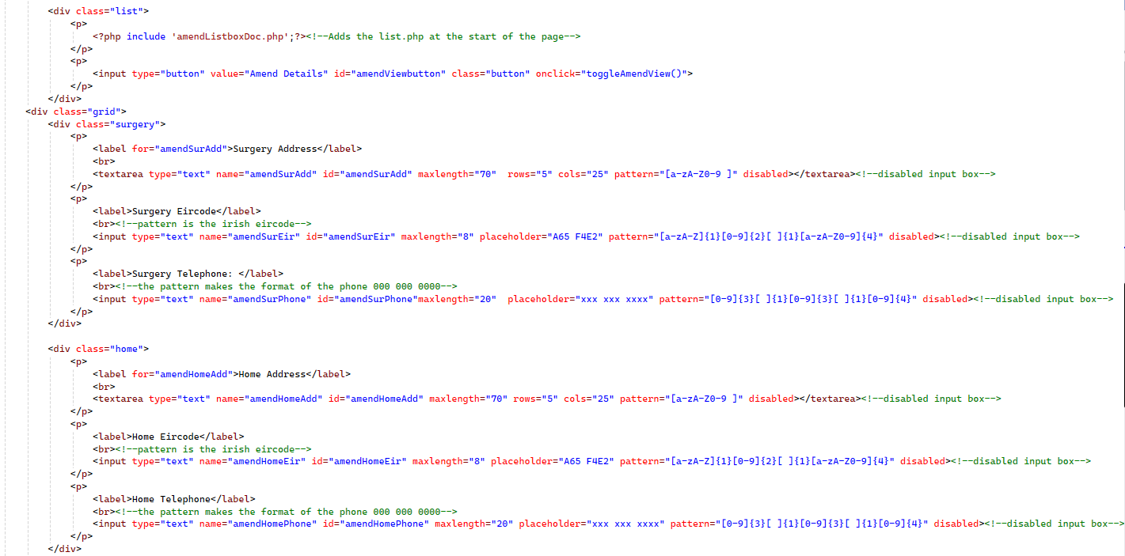

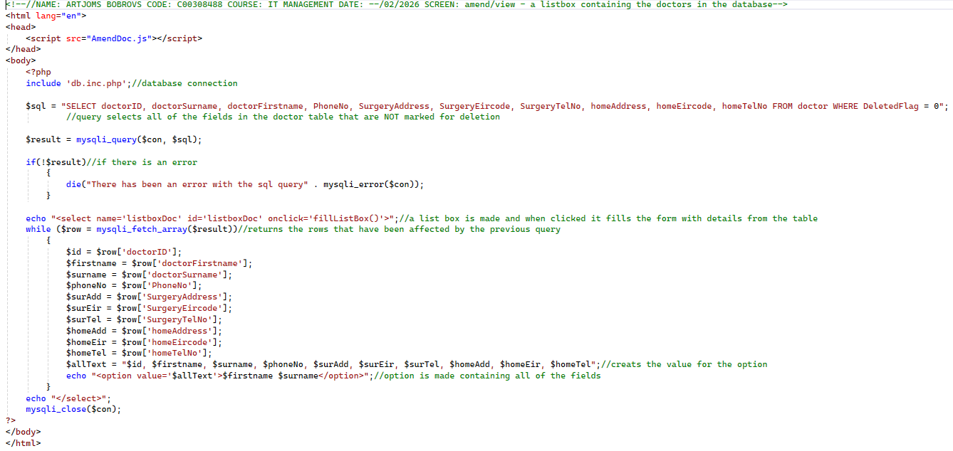
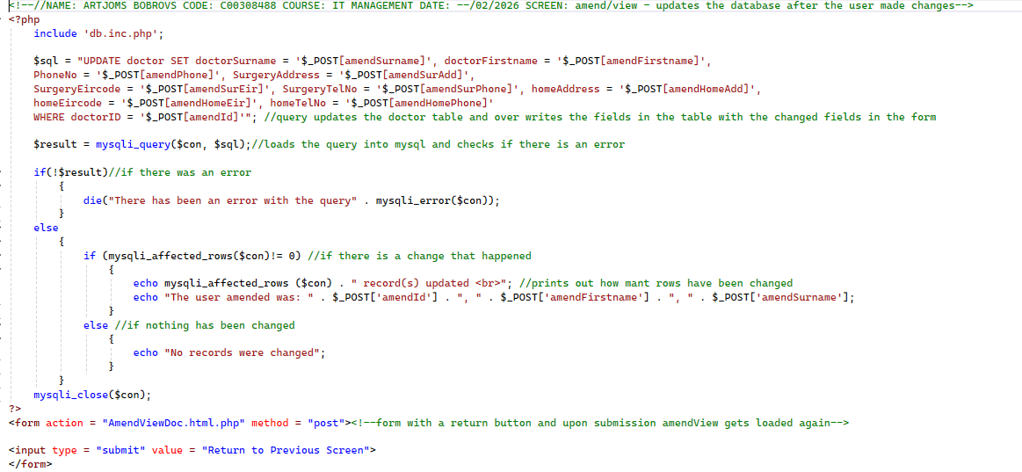
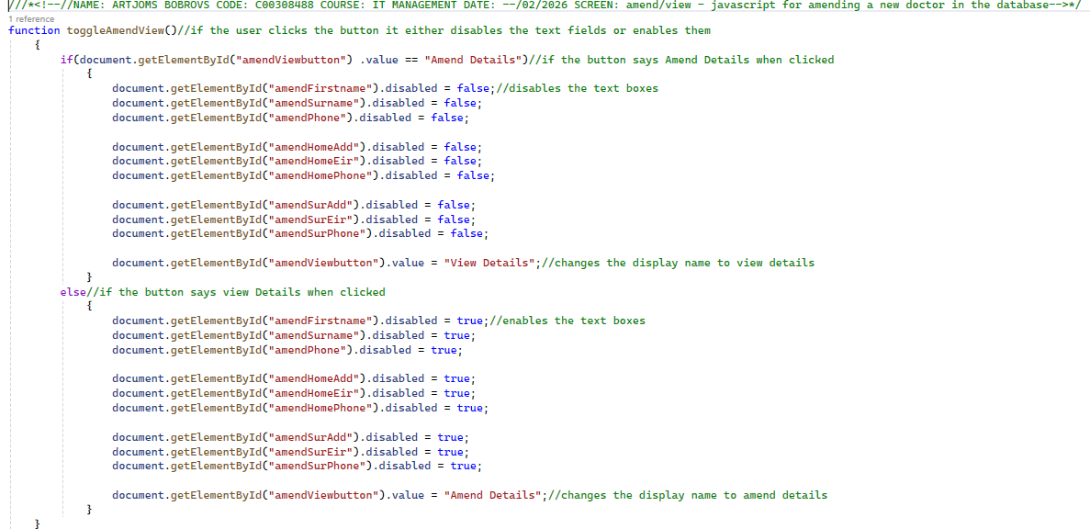
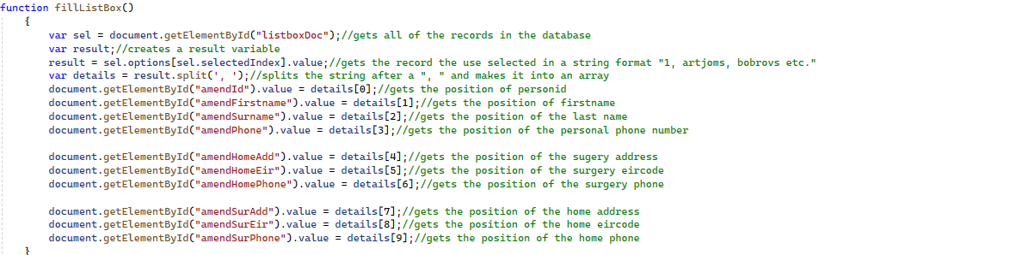
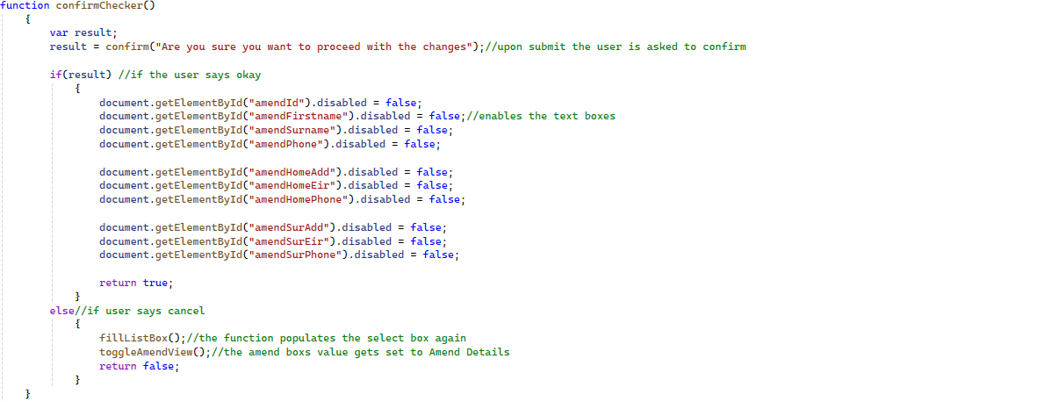
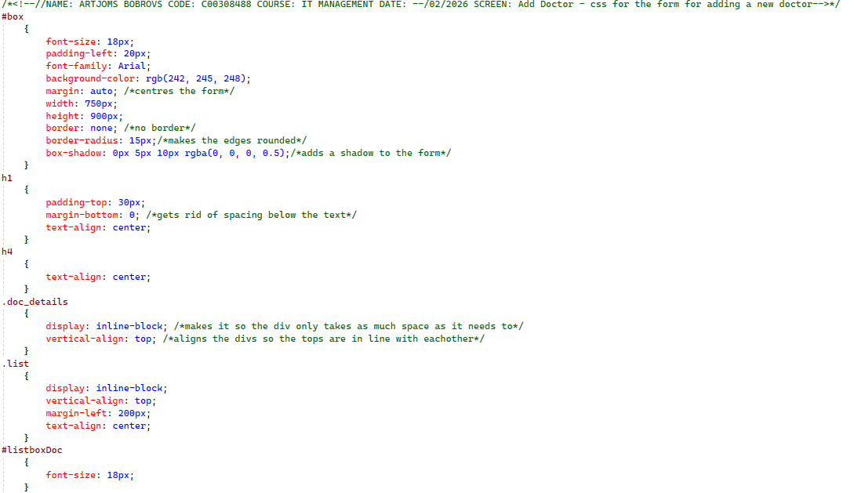
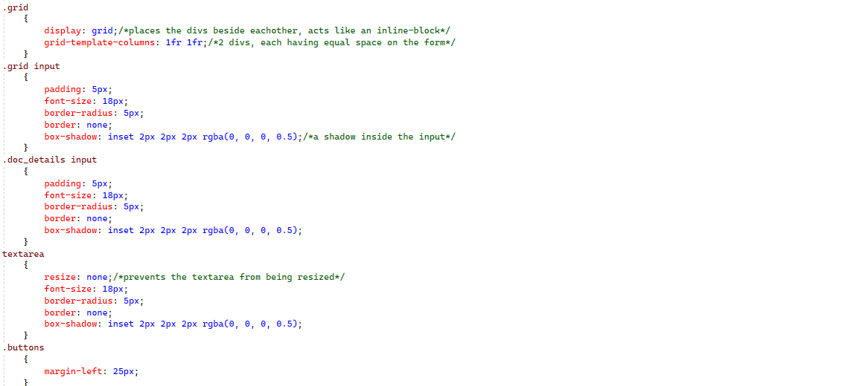
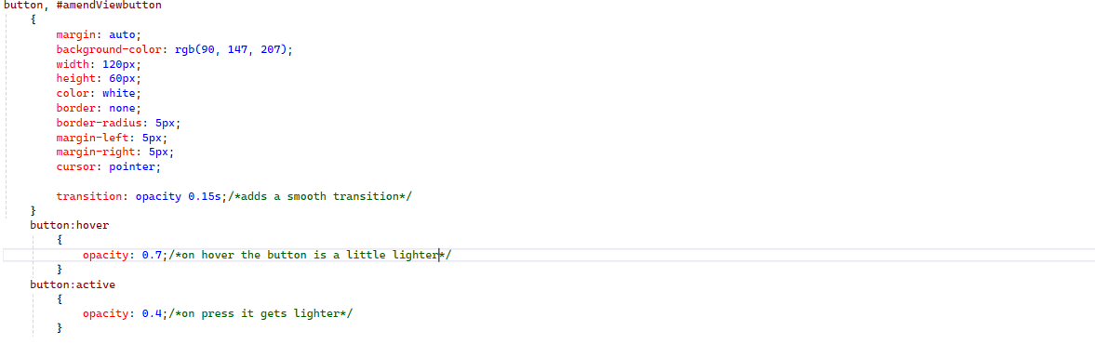
Delete Screen:
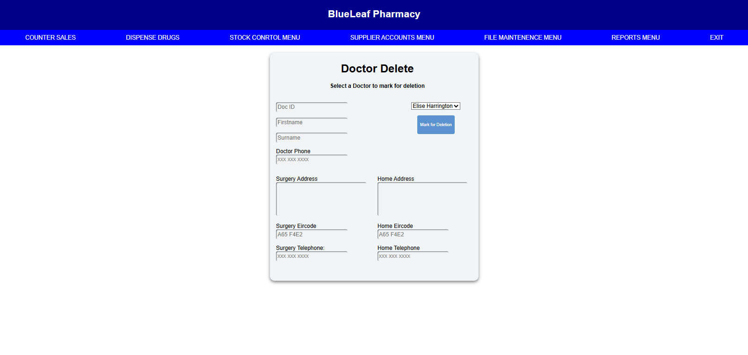
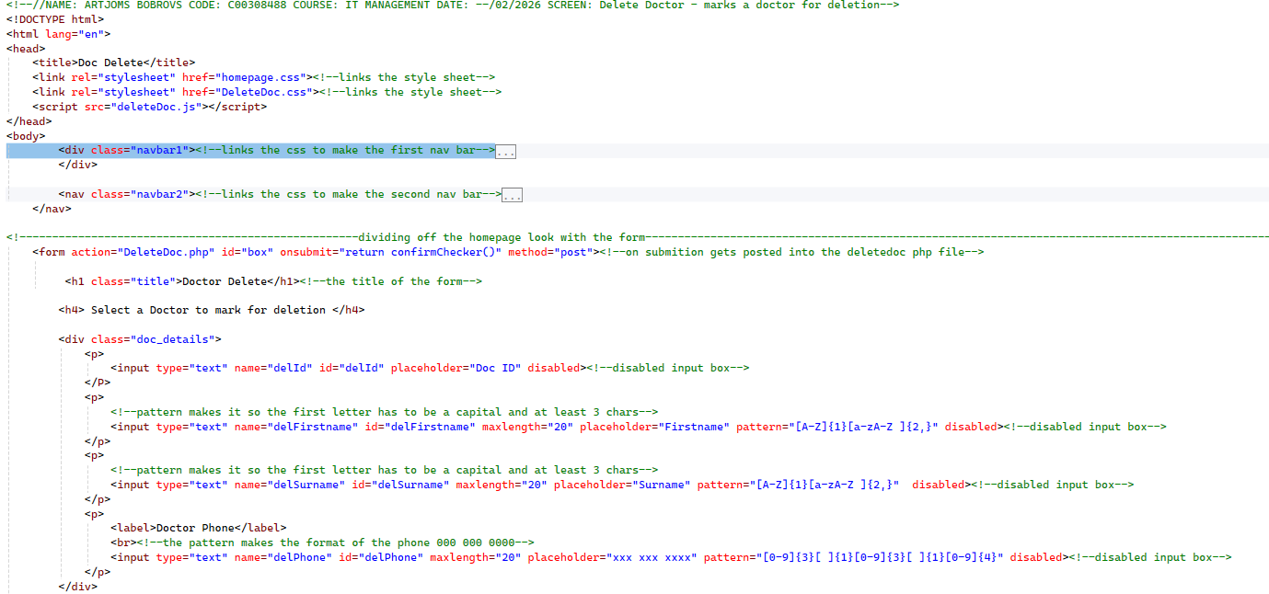
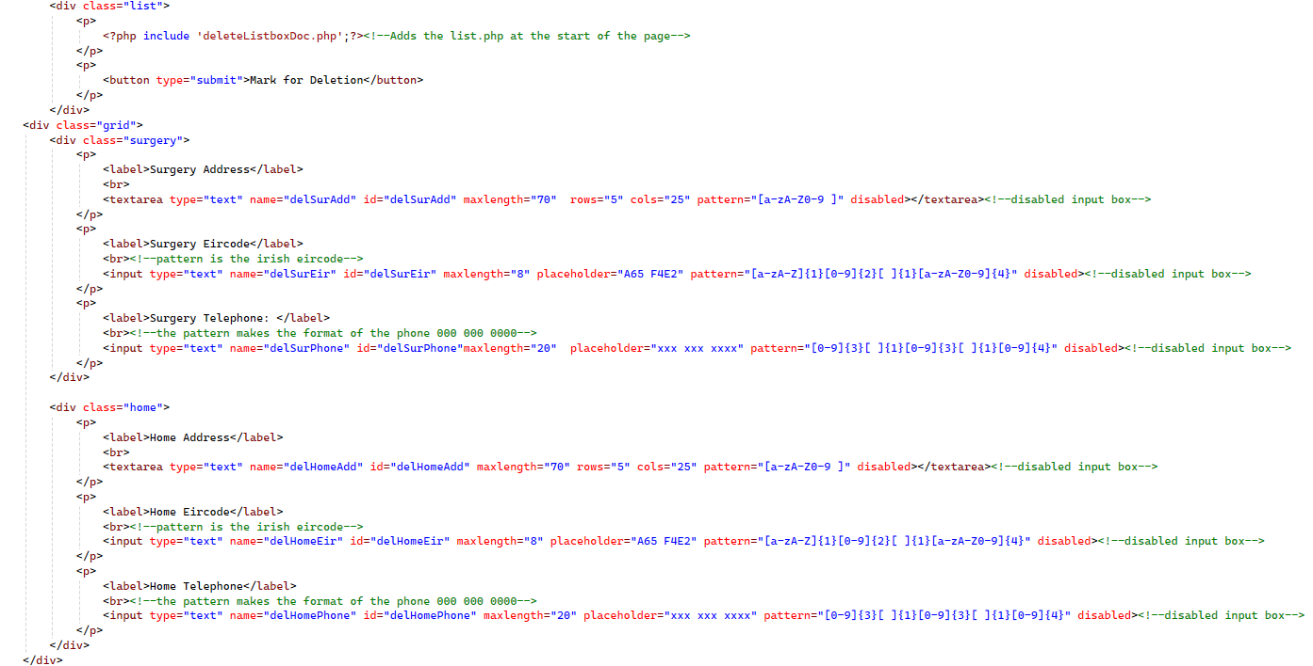

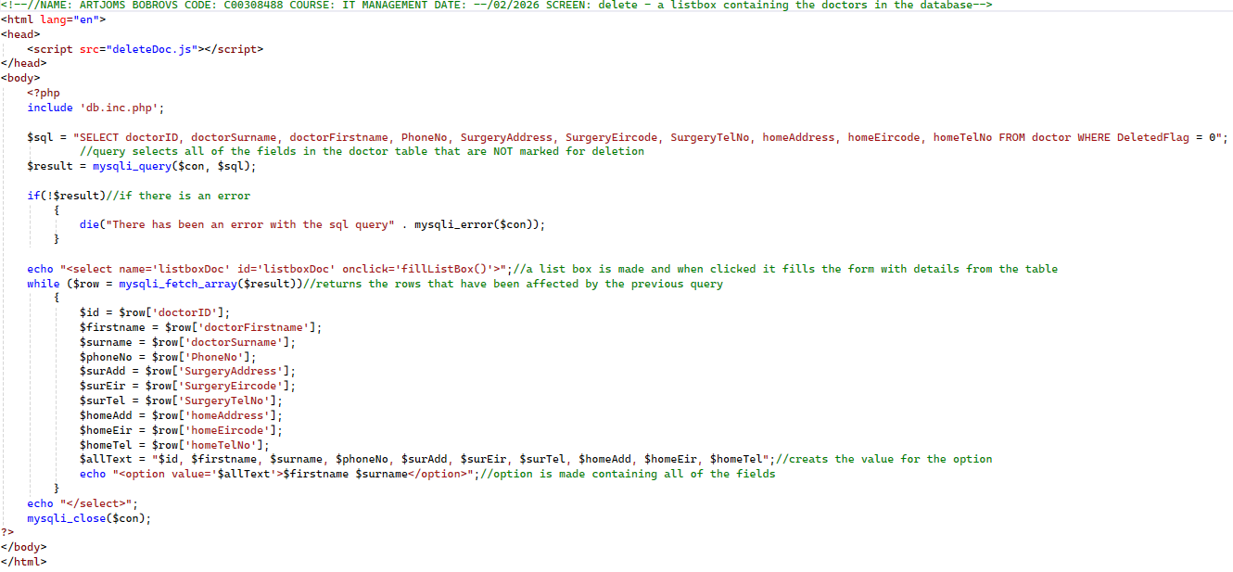
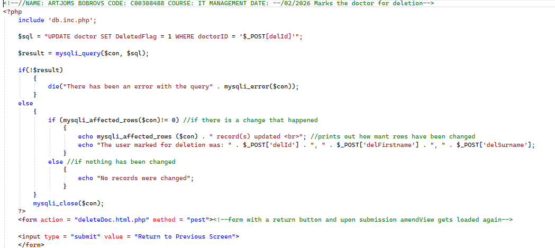
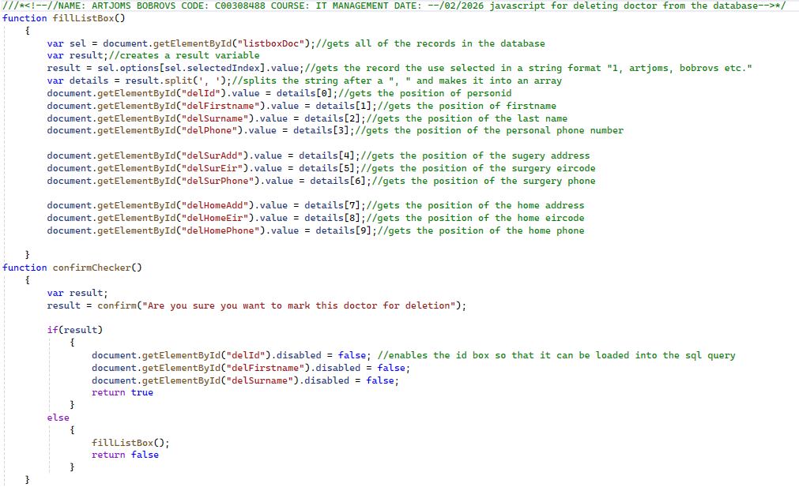
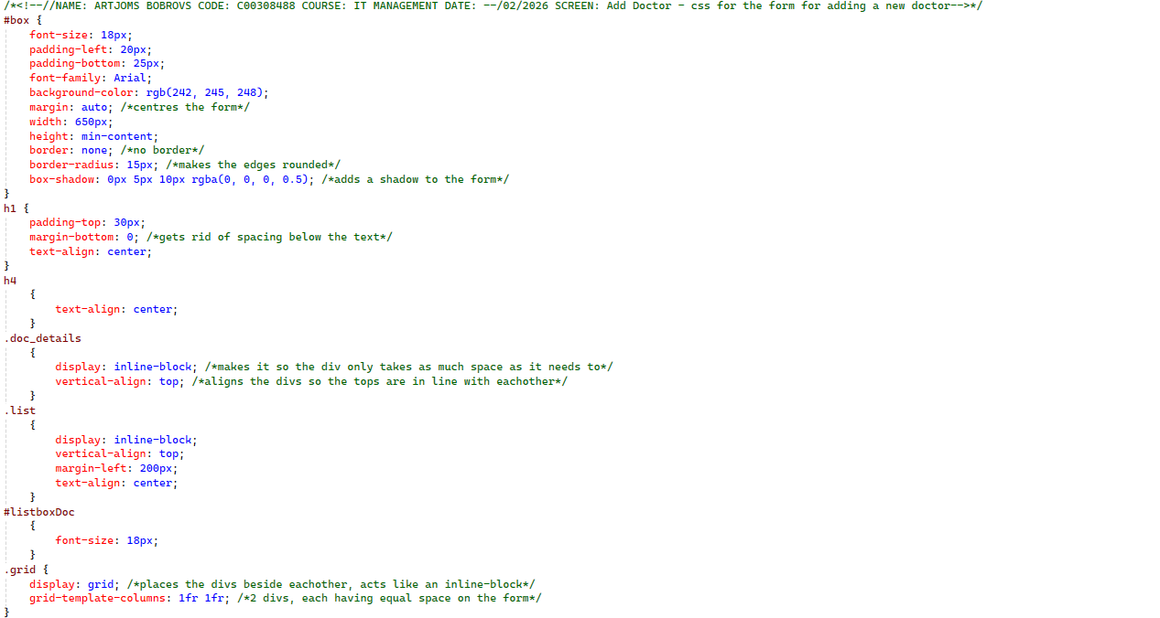
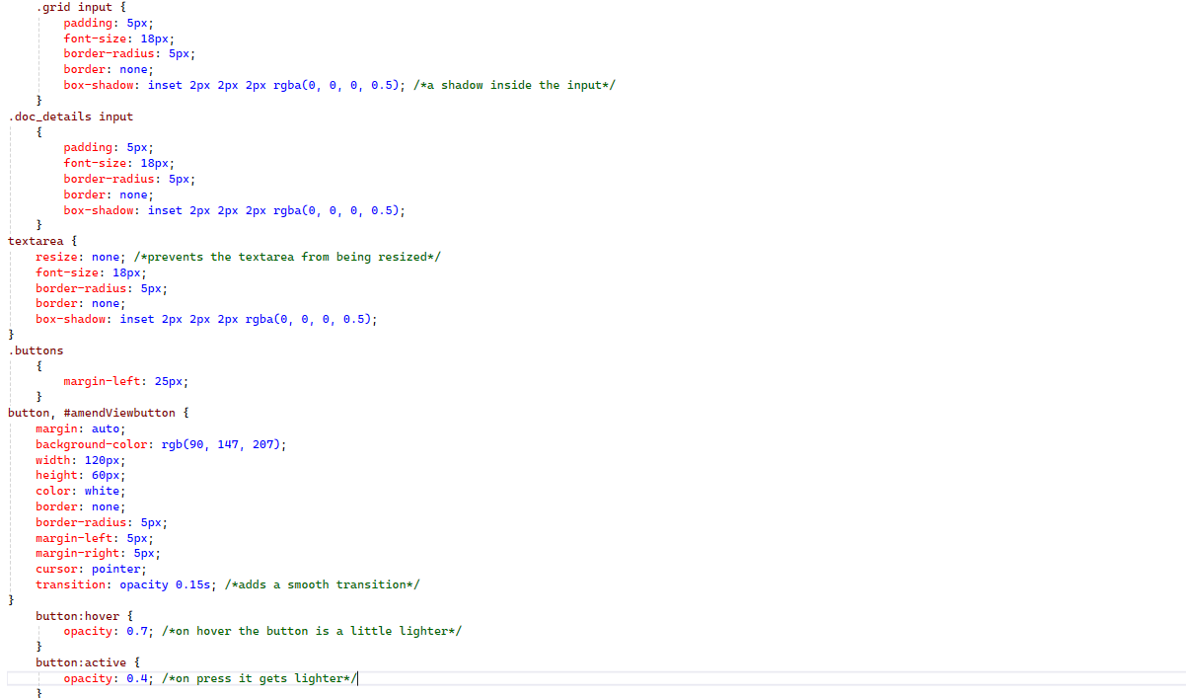
Reorder Screen:
